1. Find the Second Largest Element (without sorting)
Input:
5
10 25 8 45 30
Output:
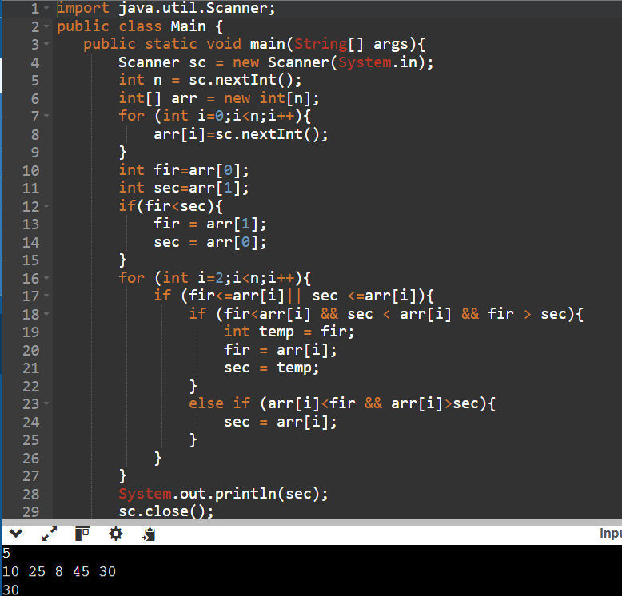
Second Largest = 30

2. Find the Second Smallest Element
Input:
6
9 2 7 5 1 8
Output:
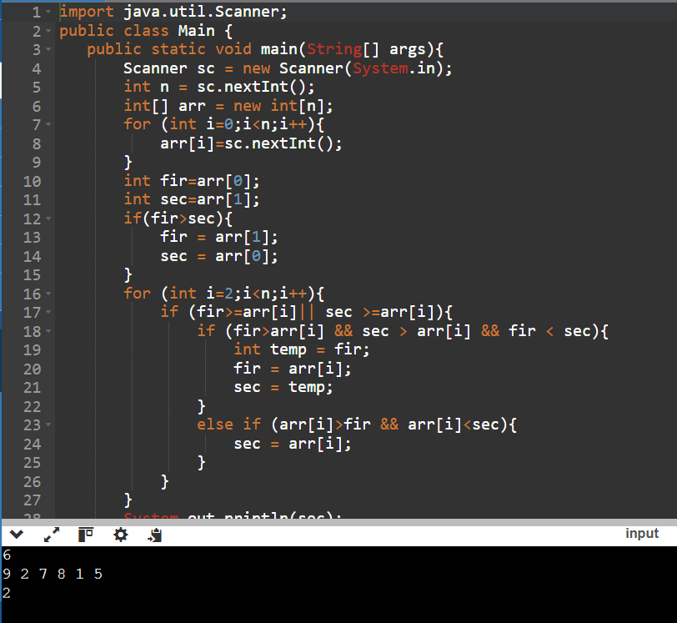
Second Smallest = 2

3. Move All Zeros to the End
Input:
1 0 5 0 8 2 0 6
Output:
1 5 8 2 6 0 0 0

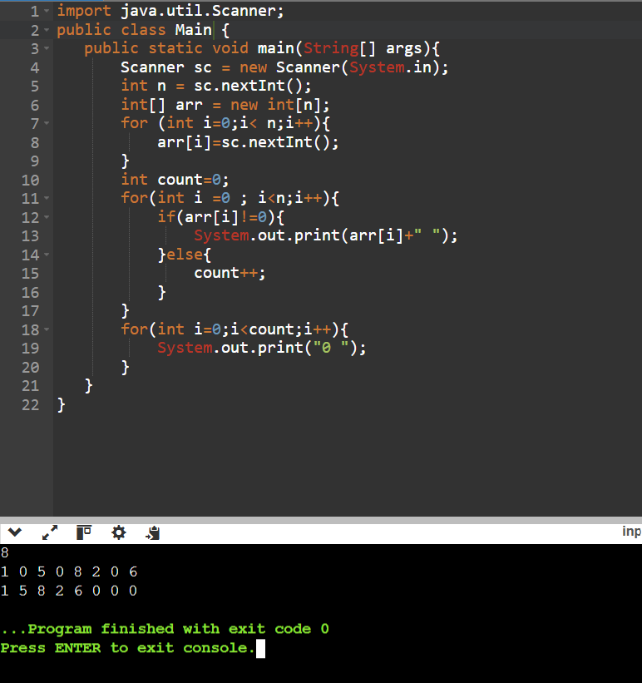

4. Rotate Array to the Left by One Position
Input:
10 20 30 40 50
Output:
20 30 40 50 10

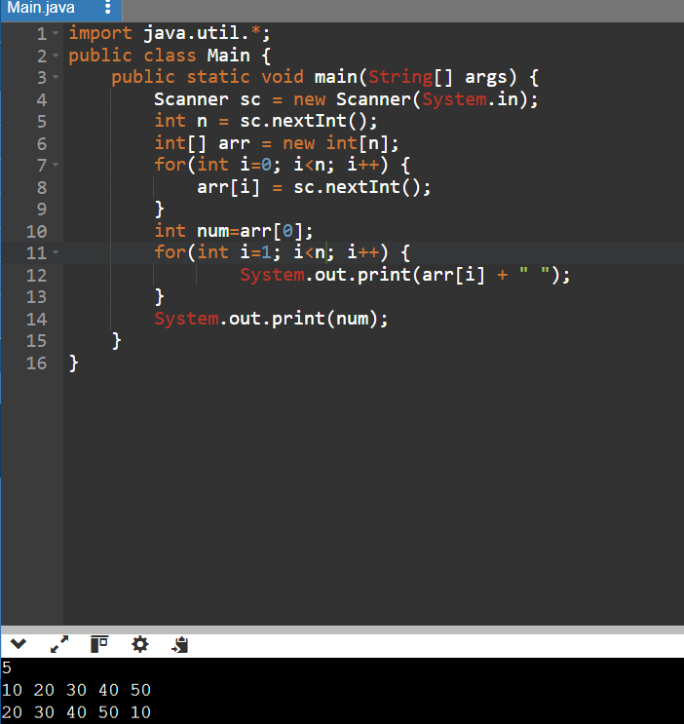
5. Rotate Array to the Right by One Position
Input:
10 20 30 40 50
Output:
50 10 20 30 40

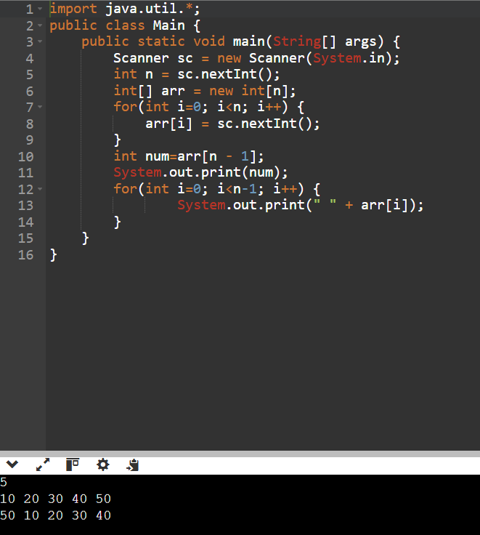

6. Find Missing Number (1 to N)
Input:
1 2 4 5 6
Output:
Missing Number = 3
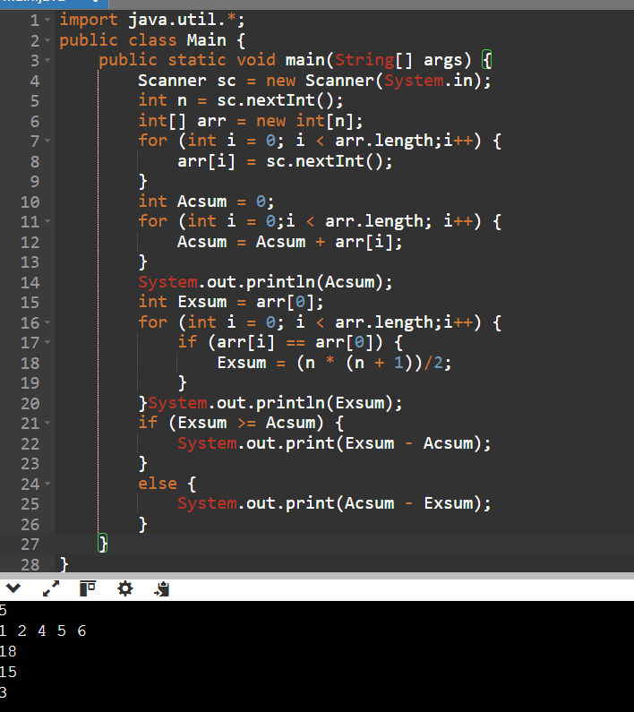
7. Find the Element that Appears Only Once
(All other elements appear twice.)
Input:
2 5 7 5 2 8 8
Output:
Unique Element = 7

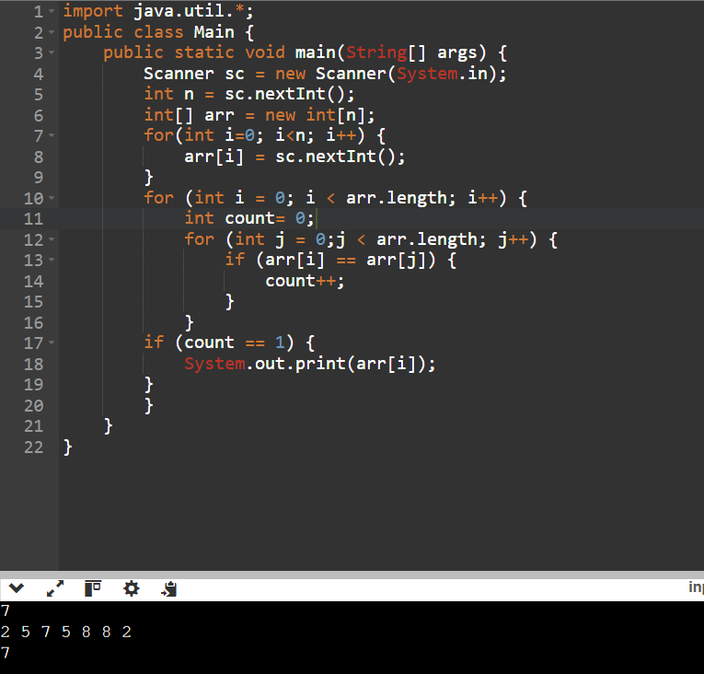
8. Find the First Repeating Element
Input:
4 2 7 8 2 5 4
Output:
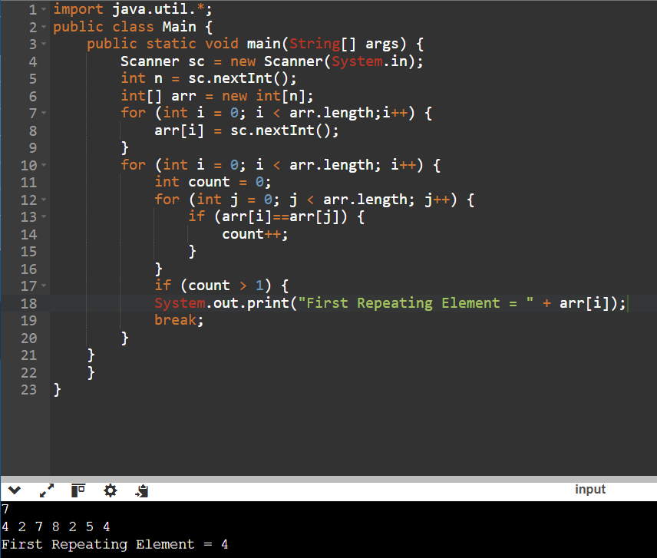
First Repeating Element = 4
9. Find the First Non-Repeating Element
Input:
2 3 4 2 3 6 7
Output:
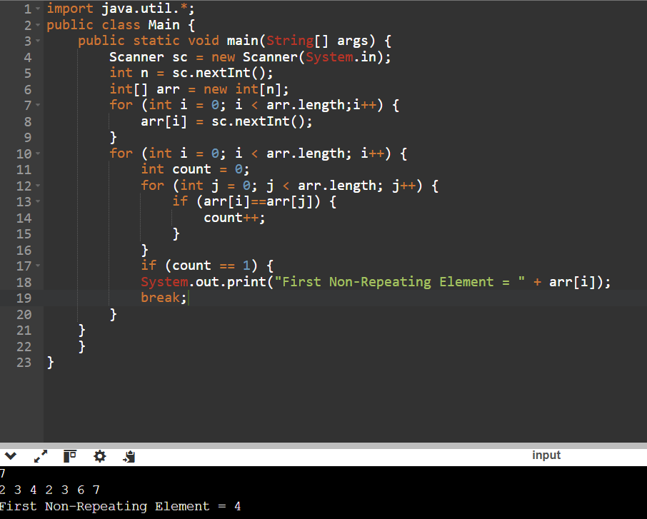
First Non-Repeating Element = 4
10. Check if Array is Sorted
Input:
5 10 15 18 20
Output:
Array is Sorted

